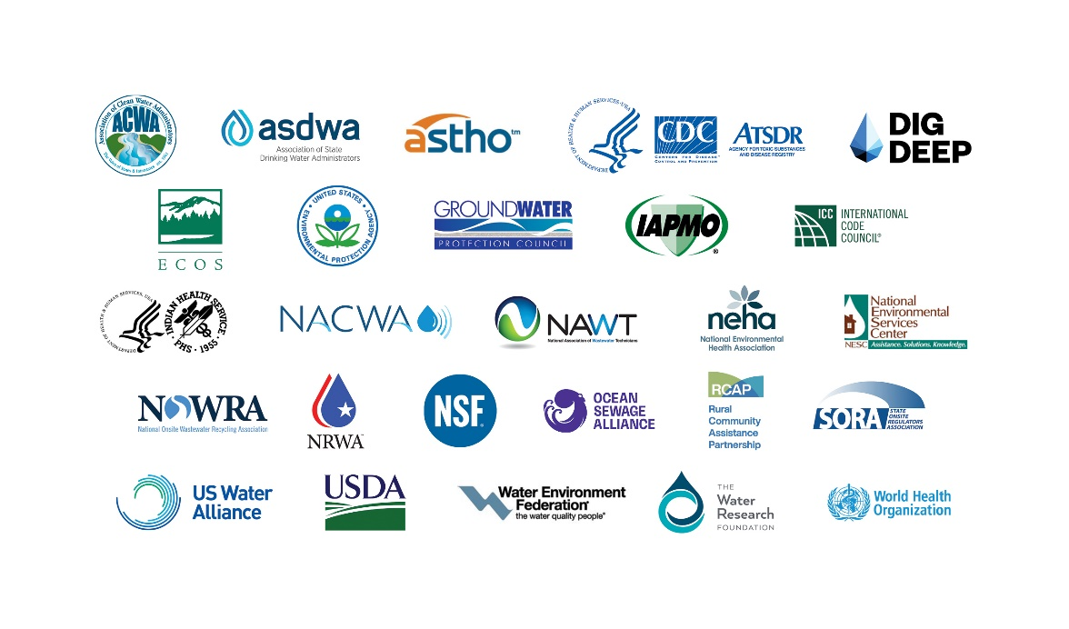

**DECENTRALIZED WASTEWATER MANAGEMENT**

**MEMORANDUM OF UNDERSTANDING BETWEEN THE U. S. ENVIRONMENTAL PROTECTION AGENCY AND PARTNER ORGANIZATIONS**

Association of Clean Water Administrators (ACWA)

Association of State and Territorial Health Officials (ASTHO)

Association of State Drinking Water Administrators (ASDWA)

Centers for Disease Control and Prevention (CDC)/National Center for Environmental Health (NCEH)/Agency for Toxic Substances and Disease Registry (ATSDR)

DigDeep

Environmental Council of the States (ECOS)

Ground Water Protection Council (GWPC)

International Association of Plumbing and Mechanical Officials (IAPMO)

Indian Health Service (IHS)

International Code Council (ICC)

National Association of Clean Water Agencies (NACWA)

National Association of Wastewater Technicians (NAWT)

National Environmental Health Association (NEHA)

National Environmental Science Center (NESC)

National Onsite Wastewater Recycling Association, Inc. (NOWRA)

National Rural Water Association (NRWA)

NSF International

Ocean Sewage Alliance (OSA)

# Rural Community Assistance Partnership (RCAP)

State Onsite Regulators Association (SORA)

U.S. Water Alliance

United States Department of Agriculture-Rural Development (USDA-RD)

Water Environment Federation (WEF)

WHO/UNICEF Joint Monitoring Programme for Water Supply, Sanitation and Hygiene (WASH)*

The Water Research Foundation (WRF)

**Background:** Across the U.S., decentralized (septic or onsite) technology can provide communities and homeowners with a safe, affordable wastewater treatment option. This is particularly true in small, suburban, and rural areas where connecting to centralized treatment is often too expensive or may not be available. Decentralized wastewater systems are used

throughout the country for both existing and new homes as well as commercial or large residential settings. Approximately 20 percent of all U.S. households (or 1 in 5 homes) are served by individual decentralized systems, according to the 2015 U.S. Census Bureau’s American Housing Survey (AHS).[1] In addition, EPA estimated (1999) there are over 350,000

large-capacity septic systems (LCSS) used in commercial developments or residential settings (20 or more people) without centralized treatment options. A 2020 study indicates

approximately one-third of new single-family homes built from 2015 to 2018 utilize decentralized systems (Onsite Wastewater Installation Assessment, National Environmental Services Center).

EPA’s “Response to Congress on the Use of Decentralized Wastewater Treatment Systems”

(1997) concluded that decentralized systems are an integral component of our nation’s wastewater infrastructure and can protect public health and water quality if they are properly

planned, sited, designed, installed, and maintained. In 2005, EPA sought to create a Memorandum of Understanding (MOU) to improve the overall performance and management of

decentralized systems through facilitated collaboration between EPA Headquarters, EPA Regions, state and local governments, and national organizations representing practitioners in

this industry. These MOU partners have effectively worked together to facilitate information

exchange on system technology, collaborate to support training efforts, promote public awareness on septic system care and maintenance, and produce materials on decentralized

systems.

This MOU reaffirms commitments made under previous MOUs signed in 2005, 2008, 2011,

2014, 2017, and 2020. EPA entered into these MOUs pursuant to Sections 104(a) and (b) of the Clean Water Act (33 U.S.C. 1254(a) and (b)) and Section 1442(a) of the Safe Drinking Water Act (42 U.S.C. 300j-1).

**Purpose:** The purpose of this MOU is to build on the successes of prior MOUs by working

collaboratively to improve the overall performance and management of decentralized systems,

continue collaborative efforts on training and certification, promote public awareness and

support education on the management of decentralized systems.

The new signatories of this MOU include the: International Code Council (ICC); National Association of Clean Water Agencies (NACWA); Ocean Sewage Alliance (OSA); United States Department of Agriculture Rural Development (USDA-RD); and WHO/UNICEF Joint Monitoring Programme for Water Supply, Sanitation and Hygiene (WASH).

**Objectives:** The objectives of this MOU renewal are to:

* Strengthen external partnerships.
* Improve decentralized wastewater treatment system performance through improved practitioner competency, management practices, researchand technology transfer.
* Improve accountability, control, and oversight through enhanced state, tribal and local program implementation.
* Improve local decision-making through improved public awareness, education programs, and information materials.
* Support the principles outlined in the 2003 “Voluntary Management Guidelines” and 2005 “Management Handbook for Decentralized Systems” developed by EPA’s Office of Wastewater Management.
* Support homeowners in small suburban or rural communities in meeting their infrastructure and development needs by providing outreach and education materials on decentralized technology.
* Improve homeowners’ understanding of the role decentralized systems play in protecting local water quality and public health.
* Improve equitable access to decentralized wastewater management options among low-income households, communities of color, tribal communities, and other groups in underserved areas.

EPA and the Signatory Organizations intend to accomplish these objectives by working collaboratively to:

* Develop effective mechanisms for information exchange on program activities, regulations, and plans for engaging members in decentralized system activities.
* Continue collaborative efforts to develop training, credentialing, and certification programs designed to improve consistency and competency among practitioners.
* Continue a public awareness effort to promote improved system performance and management.
* Develop materials for organizations interested in considering, planning or implementing decentralized systems for community wastewater treatment needs.

The activities and core priorities of EPA and the Signatory Organizations for this MOU period are explained in Appendix A.

**Duration of Agreement:** This Memorandum of Understanding is to take effect upon signing by the parties and remain in effect for a period of three years. This MOU may be extended or modified at any time, per the mutual written consent of the Signatory Organizations. Additionally, a Signatory Organization may terminate its participation in the MOU at any time by providing written notice to EPA and the other Signatory Organizations at least 30 days in advance of the desired termination date. The obligations the parties agree to in limits 5 and 6 below will continue after other provisions of this MOU have been terminated.

Limits:

1. This MOU is a voluntary agreement that expresses the good-faith intentions of the parties and, with the exception of the provisions addressing intellectual property, is not intended to be legally binding, does not create any contractual obligations, and is not enforceable by any party.
2. All commitments made by EPA, CDC, IHS, USDA-RD, or WHO/UNICEF in this MOU are subject to the availability of appropriated funds. Nothing in this MOU, in and of itself, obligates EPA, CDC, IHS, USDA-RD, WHO/UNICEF, or the other Signatory Organizations to expend appropriations or to enter into any contract, assistance agreement, interagency agreement, or to incur other financial obligations that would be inconsistent with their budget priorities. The Signatory Organizations agree not to submit a claim for compensation for services rendered to EPA, CDC, IHS, USDA-RD, or WHO/UNICEF in connection with any activities it carries out in furtherance of this MOU. This MOU does not exempt the Signatory Organizations from Federal Signatory Organizations’ policies governing competition for assistance agreements. Any transaction involving reimbursement, or contribution or transfer of funds between the parties to this MOU will be handled separately, in accordance with applicable laws, regulations, and procedures under separate written agreements.
3. Under Federal ethics rules, federal employees may not, with limited exceptions, endorse or promote products or services offered by or provided by any non-Federal entities. Nothing in this MOU constitutes an endorsement by EPA, CDC, IHS, USDA-RD, or WHO/UNICEF of any non-federal entity, including any products or services, or any fundraising activity or promotion. The non-Federal Signatory Organizations agree not to make statements to the public at workshops and meetings, in promotional literature, on their web sites or through any other media that imply that EPA, CDC, IHS, USDA-RD, WHO/UNICEF or any of their employees endorses the non-Federal Signatory Organizations or any of their services or products. In addition, the non-Federal Signatory Organizations agree not to make statements that imply that EPA, CDC, IHS, USDA-RD, or WHO/UNICEF supports their efforts to raise public or private funds. Any statements or promotional materials prepared by the non-Federal Signatory Organizations that describe this MOU must be approved in advance by EPA.
4. This MOU does not create any right or benefit, substantive or procedural, enforceable by law or equity by persons who are not party to this agreement, against EPA or the Signatory Organizations, their officers or employees, or any other person. This MOU does not apply to any person outside of EPA or the Signatory Organizations.
5. This MOU does not supersede, alter, supplement, vary or otherwise change financial assistance agreements entered into by EPA, CDC, IHS, USDA-RD or WHO/UNICEF with any of the Signatory Organizations, including the states. It does not relieve any of the non-Federal Signatory Organizations or states of obligations or duties contained in law, regulations, or financial assistance agreements.
6. The parties agree that any copyrightable subject matter, including but not limited to journal articles, training, educational material or software, created jointly by the parties from the activities conducted under the MOU may be copyrighted by any non-Federal Signatory Organization. The non-Federal Signatory Organizations hereby grant to the United States government a royalty-free, nonexclusive, irrevocable right to reproduce, distribute, make derivative works, and publish and perform the work(s) publicly, or to authorize others to do so on its behalf.
7. The parties agree that any patented invention created by any Signatory Organization pursuant to the terms of this MOU will be jointly owned by the parties regardless of inventorship, unless an alternative agreement indicates otherwise.

**Acceptance:** The undersigned agree, on this 5th day of December 2023, to the program described in this Memorandum of Understanding.

|  |  |  |  |
| --- | --- | --- | --- |
| Julia Anastasio  Executive Director & General Counsel  Association of Clean Water Administrators | | Michael Fraser  Chief Program Officer, Health Security  Association of State and Territorial Health Officials | |
| Alan Robertson  Executive Director  Association of State Drinking Water Administrators | | Aaron Bernstein  Director  National Center for Environmental Health/Agency for Toxic Substances and Disease Registry  Centers for Disease Control and Prevention | |
| Kabir Thatte  Executive Director  DigDeep | | Ben Grumbles  Executive Director  Environmental Council of the States | |
| Dan Yates  Executive Director  Ground Water Protection Council | | Dain Hansen  Executive Vice President of Government Relations  International Association of Plumbing and Mechanical Officials | |
| Matt Sigler  PMG Executive Director  International Code Council | | Adam Krantz  Chief Executive Officer  National Association of Clean Water Agencies | |
| John Ferdetta  President  National Association of Wastewater Technicians | | David T. Dyjack  Executive Director  National Environmental Health Association | |
| Kevin Orner  Assistant Professor  National Environmental Services Center | | Allison Blodig  President  National Onsite Wastewater Recycling Association | |
| Vern Steel  Deputy Chief Executive Officer  National Rural Water Association | | Harold Chase  Director, Government Affairs  NSF International | |
| Stewart Sarkozy-Banoczy  Acting Executive Director/Steering Committee Chair  Ocean Sewage Alliance | | Ted Siger  Executive Director  Rural Community Assistance Partnership | |
|  | |
| Eric Casey  Executive Director  State Onsite Regulators Association | | Mami Hara  Chief Executive Officer  US Water Alliance | |
| Kathleen Waugh  Chief Operating Officer  Water Environment Federation | | Peter Grevatt  Chief Executive Officer  The Water Research Foundation | |
| Farah Ahmad  Deputy Undersecretary  United States Department of Agriculture-Rural Development | | Roselyn Tso  Director  Indian Health Service | |

Benita Best-Wong

Deputy Assistant Administrator

Office of Water

US Environmental Protection Agency

**Appendix A**

**MOU Partnership Activities and Core Priority Areas**

**EPA and the Signatory Organizations’ Activities**

Consistent with the limits described in the MOU, EPA and the Signatory Organizations intend to:

* Participate in MOU partner conference calls (at least one representative from each Signatory Organization) and meetings as scheduled.
* Promote core partnership activities related to decentralized systems, such as EPA’s SepticSmart Week and quarterly MOU-sponsored webinars through appropriate communication vehicles.
* Inform members that they have joined the MOU partnership (for new partners) or that they have re-signed the MOU renewal agreement (for existing partners).
* Establish web links on their organization’s website to the other MOU partners’ websites, as appropriate.
* Provide information to their staff about this MOU as permitted by their employers and encourage them to become knowledgeable about decentralized wastewater systems.
* Encourage involvement in MOU partner activities at their organization’s conferences through advertisement on newsletters, website, etc., related to partnership activities.
* As appropriate, invite MOU partners to speak, participate, and/or exhibit at their organization’s conferences and encourage an MOU partner spotlight during regularly scheduled partner conference calls.

**Core Priorities of this MOU Partnership**

EPA and the Signatory Organizations have identified the following core priorities that they intend to emphasize during the 2023 – 2026 MOU period:

**Education & Outreach**

* Increase public education and outreach through EPA’s SepticSmart program to ensure septic/ decentralized wastewater systems are properly used and maintained to protect water quality and human health.

**Technical Assistance for Underserved/ Disadvantaged Communities**

* Promote technical assistance (TA) resources and foster connections between TA providers and underserved communities and tribes to support the design, construction, and financing of sustainable decentralized wastewater infrastructure.

**Resiliency & Sustainability**

* Showcase research, information and technologies that demonstrate how innovative approaches can help decentralized systems become more resilient to climate change and natural disasters, and sustainable for the long term.

**Data Collection & Application**

* Utilize federal and MOU partners’ networks to collect, analyze and apply varying types of decentralized system data.

**Workforce & Training**

* Expand mechanisms to address the workforce and training needs in the decentralized wastewater industry.

1. While more recent data on individual decentralized system usage was collected in the 2017, 2019, and 2021 AHS, it likely undercounts the number of systems in use across the United States. For example, according to 2017 data, 17.8 percent of U.S. households rely on decentralized systems, but due to the longitudinal survey design, changing sample selection, and other factors, this is likely an underestimation. <https://www.epa.gov/system/files/documents/2022-01/low-mod-income-without-treatment_report-to-congress.pdf>