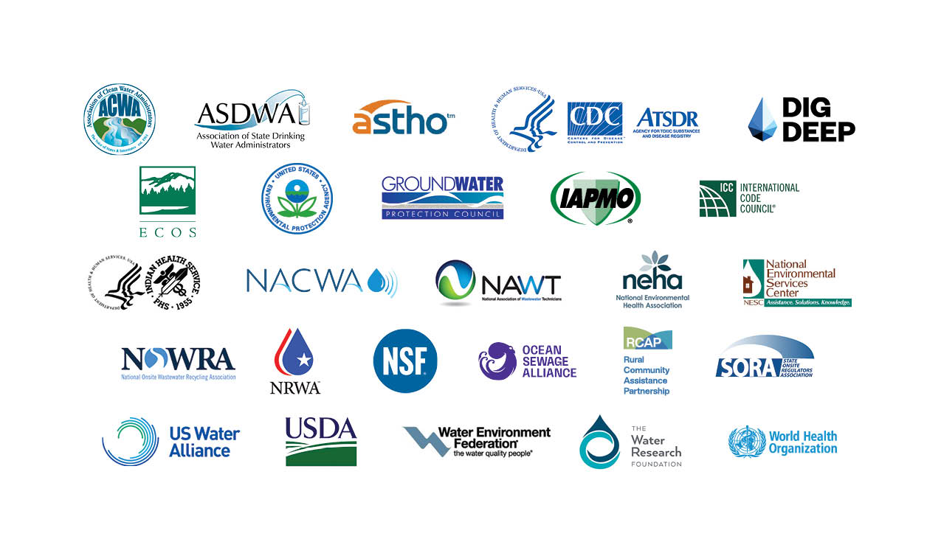

**2023 EPA Decentralized Wastewater MOU Partners**

**Mission: To improve the overall performance and management of decentralized systems, continue collaborative efforts on training and certification, promote public awareness and support education on the management of decentralized wastewater systems.**

[**Association of Clean Water Administrators (ACWA):**](https://www.acwa-us.org/) As the national voice of state and interstate water programs, ACWA strives to protect and restore watersheds to achieve clean water everywhere for everyone.

[**Association of State and Territorial Health Officials (ASTHO):**](https://www.astho.org/)To support, equip and advocate for state and territorial health officials in their work of advancing the public’s health and well-being.

[**Association of State Drinking Water Administrators (ASDWA):**](https://www.asdwa.org/) ASDWA is the professional association that supports state and territorial drinking water programs in their efforts to protect public health through the provision of safe drinking water.

[**Centers for Disease Control and Prevention (CDC)/National Center for Environmental Health (NCEH)/Agency for Toxic Substances and Disease Registry (ATSDR):**](https://www.cdc.gov/nceh/) NCEH/ATSDR protects people’s health from environmental hazards that can be present in the air we breathe, the water we drink, and the world that sustains us. We do this by investigating relationships between environmental factors and health, developing guidance, and building partnerships to support healthy decision making.

[**DigDeep:**](https://www.digdeep.org/)DigDeep is a human rights organization working to ensure that every American has equitable access to water and sanitation forever.

[**Environmental Council of the States (ECOS):**](https://www.ecos.org/)To enhance the capability of State environmental agencies and their leaders to protect and improve human health and the environment.

[**Ground Water Protection Council (GWPC):**](https://www.gwpc.org/)To promote the protection and conservation of groundwater resources for all beneficial uses.

[**International Association of Plumbing and Mechanical Officials (IAPMO):**](https://www.iapmo.org/) We strive to be the industry leader in protecting public health and safety and in improving access to safe and sustainable water and sanitation around the world.

**[Indian Health Service (IHS):](https://www.ihs.gov/)** To raise the physical, mental, social and spiritual health of American Indians and Alaska Natives (AI/AN) to the highest level.

[**International Code Council (ICC):**](https://www.iccsafe.org/) To provide information, tools and resources that members rely on, building safety professionals turn to, and the public trusts.

[**National Association of Clean Water Agencies (NACWA):**](https://www.nacwa.org/home)NACWA represents public wastewater and stormwater agencies of all sizes nationwide.

[**National Association of Wastewater Technicians (NAWT):**](https://www.nawt.org/index.html)To unify the voice of the sanitary liquid waste management industry for the betterment of members, the environment and the general public.

[**National Environmental Health Association (NEHA)**](https://www.neha.org/)To build, sustain and empower an effective environmental health workforce.

[**National Environmental Science Center (NESC):**](https://actat.wvu.edu/)NESC programs are devoted to protecting the public health and environment of small communities and rural areas.

[**National Onsite Wastewater Recycling Association, Inc. (NOWRA):**](https://www.nowra.org/)To strengthen and promote the onsite and decentralized wastewater industry and achieve greater public awareness of the economic, environmental and public health benefits of onsite decentralized facilities.

[**National Rural Water Association (NRWA):**](https://nrwa.org/)To strengthen State Associations and support efforts to ensure rural communities have access to safe drinking water and clean wastewater treatment.

[**NSF**](https://www.nsf.org/)**:** To improve human and planet health through the development of public health standards and services that help protect the world’s food, water, consumer products and environment.

[**Ocean Sewage Alliance (OSA):**](https://www.oceansewagealliance.org/)The mission of the Ocean Sewage Alliance is to eliminate sewage and wastewater pollution from our ocean and waterways, advancing equitable and holistic actions that benefit people and nature.

[**Rural Community Assistance Partnership (RCAP):**](https://www.rcap.org/)To elevate rural voices and build local capacity to improve quality of life, starting at the tap.

[**State Onsite Regulators Association (SORA):**](http://www.soraus.com/)To advance the field of knowledge and practice of those who regulate onsite wastewater programs.

[**U.S. Water Alliance:**](https://uswateralliance.org/)To inspire and sustain a diverse movement to advance transformative solutions to pressing water challenges so communities can thrive.

[**United States Department of Agriculture Rural Development (USDA-RD):**](https://www.rd.usda.gov/) U.S. Department of Agriculture Rural Development (RD), under the leadership of the Biden-Harris Administration, champions the economic prosperity, sustainability, and health of rural families and their communities. Leveraging partnerships and federal resources targeting water and wastewater infrastructure throughout rural America is a key part of this work.

[**Water Environment Federation (WEF):**](https://www.wef.org/)WEF provides water quality professionals around the world with the latest in water quality education, training and business opportunities.

[**WHO/UNICEF Joint Monitoring Programme for Water Supply, Sanitation and Hygiene (WASH**](https://washdata.org/)**)**: To produce reliable estimates of national, regional and global progress on WASH to inform decision making by government, donor and civil society organizations.

[**The Water Research Foundation (WRF):**](https://www.waterrf.org/)WRF is the leading research organization advancing the science of all water to meet the evolving needs of its subscribers (drinking water, wastewater, reuse, and stormwater systems) and the water sector.